Operational Guidelines for the Laboratory Animal Urinalysis Service

- The Operational Guidelines for the Laboratory Animal Urinalysis Service were established to maximize the utility and effectiveness of the device mentioned herein.
- Details of this device are as follows:
- Brand and type: IDEXX UA Analyzer
- Performance:
- A reflection spectrophotometer is used to read the IDEXX UA™ Strips.
- Light-emitting diodes are used to emit light of a certain wavelength to the surface of the test strip at the optimal angle, and then, asemiquantitative result is output.
- The analysis result of a sample can be obtained within approximately 80 seconds.
- The device is located in the Laboratory Animal Center on the first floor of the Back Building of the United Medical Building.
- The main service targets of the device are researchers from Taipei Medical University and its three associated hospitals.
- Service items of this device consist of the following eight urinalysis parameters.
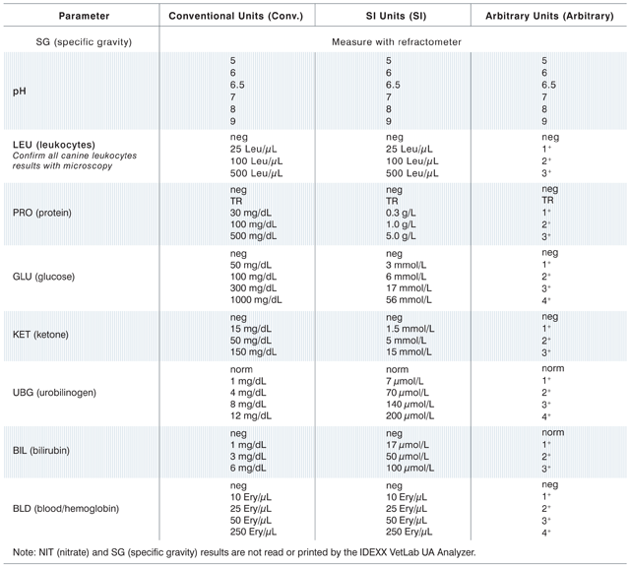
- Reservation methods:
- Please register use of the device in the reservation systems of the Core Facility Center or Laboratory Animal Center 1–10 days prior to the prescheduled service day. The Laboratory Animal Center technician provides services according to actual reservation situations.
- Technical service time: Monday to Friday, 09:00 a.m. to 05:00 p.m.
- The guidelines for using the device are as follows:
- Analytical reports of this service are provided in hard copies.
- The UA analyzer uses urine samples for testing. The basic sample volume is 200 μL.
- The collected urine sample should be delivered for analysis as soon as possible. If force majeure occurs, the user must notify the technicians immediately and store the sample at 4°C; the full operation should be completed within 2 hours of sample collection. Users must manage the sampling and operation times appropriately to avoid compromising testvalues.
- The charging standard of this device is determined to ensure optimal service quality and extend the effective service duration of the device. Upon resolution of a Meeting of the Office of Research and Development, individuals or units that use the device must pay for necessary consumables, maintenance, and operator services of the device

- Charging standard: NT$50 per sample.
- Payment method: Laboratory Animal Center calculates technical service uses and relevant fees after every useand sends payment notices to users. Users must pay and verify the technical service fees within 3 months of the payment notice being issued. Users can visit the Cashier Section of Taipei Medical University to pay the fees, or have their expenditures charged from research project funds or school budgets.

- Device contact person:
Laboratory Animal Center technician: Wang, Chueh-Yi, extension: 7153
Wu, Wen-Chi, extension: 7152

- These Guidelinesshall be implemented upon approval by an Office Meeting of the Office of Research and Development; the same procedure applies to any amendment.

